RESOLUTION NO.__________

RE: CERTIFICATE OF APPROPRIATENESS UNDER THE
PROVISIONS OF THE ACT OF THE PENNSYLVANIA
LEGISLATURE 1961, JUNE 13, P.L. 282 (53
SECTION 8004) AND BETHLEHEM ORDINANCE NO.
3952 AS AMENDED.

WHEREAS, it is proposed to install signs at 1 E. Fourth Street.

NOW, THEREFORE, BE IT RESOLVED by the Council of the City of Bethlehem that a Certificate of Appropriateness is hereby granted for the work.

Sponsored by: (s)

(s)

ADOPTED BY COUNCIL THIS DAY OF

(s)
President of Council

ATTEST:

(s)
City Clerk

HISTORIC CONSERVATION COMMISSION

CASE # 533 – It is proposed to install signs at 1 E. Fourth Street
OWNER/APPLICANT: Nirav Patel/ FastSigns

The Commission upon motion by Mr. Cornish seconded by Mr. Lader adopted the proposal that City Council issue a Certificate of Appropriateness for the proposed work described herein:

- The proposal to install signs at 1 E. Fourth Street was presented by FastSigns.
- The new signs will read “Auntie Anne’s” in blue lettering with a blue border and a pretzel logo on an Ivory or other light color background. The background color must be submitted to the Historic Officer for approval.
- Both signs will be reduced in size to fit within the panel molding of the smaller panels on either side of the corner entrance. This option is preferred by the HCC since it would be more historically appropriate in terms of scale.
- On the New St. Side the sign was also approved in the proposed larger, horizontal format. The sign, however, must be reduced from the proposed size 30” x 90” to fit within the panel molding of the larger panel adjacent to the “Subway” sign.
- The signs will be ½” thick acrylic panels with the letters attached flat to the background panels.
- The new signs will not be illuminated.

- The proposed motion was unanimously approved.

CU: cu
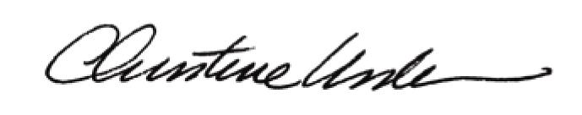

By:

Date of Meeting: February 18, 2015 Title: Historic Officer

